Dear

Re:

My patient has consulted this practice for ongoing dental treatment. We understand that you hold records pertaining to previous treatment.

To assist us in providing the most appropriate treatment, we ask for your help in supplying copies of dental records and relevant radiographs.

To ensure compliance with the State and Federal Legislation, the patient's signed consent to this request is supplied below.

We appreciate your acceding to the request within the next week. If you foresee any problems in providing assistance, please contact us as soon as possible.

Please advise the patient of any fees which may be incurred under the Privacy Regulations.

Thank you for your assistance.

Kind regards,

Dr Chris Wooldridge

Dr Paul Gleeson

Dr Emma Barnsley

Dr Raoul Harrison

Miss Skye Greenhill

*I give permission Dr Chris Wooldridge/Dr Paul Gleeson/ Dr Emma Barnsley/ Dr Raoul Harrison and Miss Skye Greenhill only to seek copies of my dental records.*

*Signature:......................................................................*

*Name:…………………………………………………...*

*Date:………….……………………..…………………..*

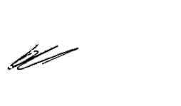 **Dr Paul Gleeson Dr Chris Wooldridge Dr Emma Barnsley Dr Raoul Harrison**

